**DATABASE DEVELOPMENT PROJECT**



**Submitted by: KHADIJA DARWAISH**

**Submitted to: SIR SHAYAN SHAH**

**Semester: 4th BSDS (Group-B)**

**Session 2023 –2027**

**INSTITUTE OF MANAGEMENT SCIENCES**

**HAYATABAD, PESHAWAR (2024)**

**1. Comprehensive Problem Statement**

**Project Title**: Event Management System

**Description:**  
Organizing events such as seminars, workshops, and concerts involves complex tasks like registration, ticketing, venue management, and feedback collection. Without a centralized system, these tasks become time-consuming, error-prone, and difficult to manage. The Event Management System addresses these challenges by providing a structured platform for event planning and execution. It supports role-based access for Admins, Organizers, and Attendees, enabling event creation, user registration, venue assignment, ticket generation, and feedback collection. The system ensures data accuracy, real-time tracking, and efficient reporting.

**Scope:**  
The system manages six core entities: Users, Events, Venues, Registrations, Tickets, and Feedback. Key features include event scheduling, registration management, and automated data handling through stored procedures and triggers.

**Why PostgreSQL:**  
PostgreSQL is used for its strong relational capabilities, data integrity features, and support for complex queries, making it ideal for managing the structured data and logic required in an event management platform.

2. **Entity-Relationship Diagram**

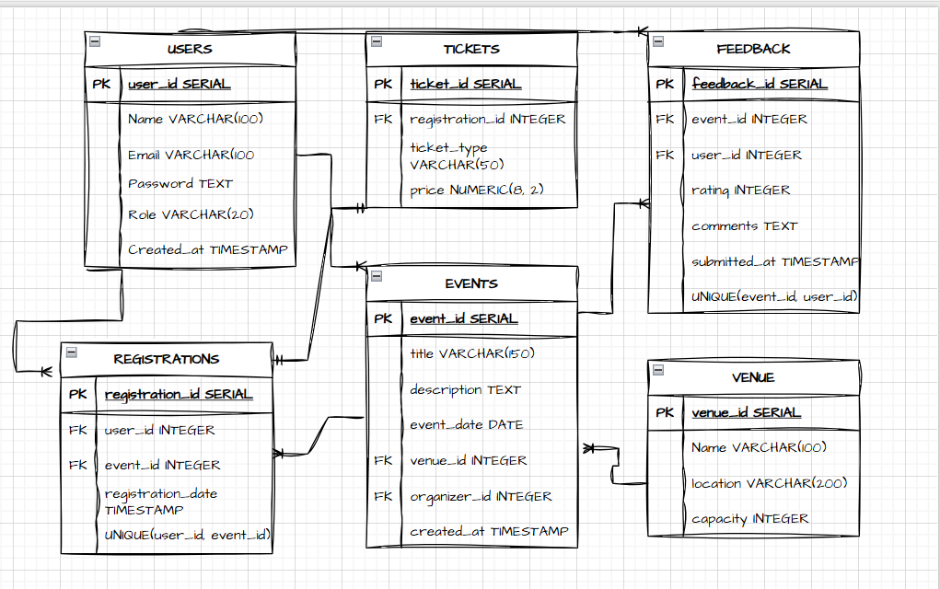

**TABLE CREATION AND DATA INSERTION**

**USERS**

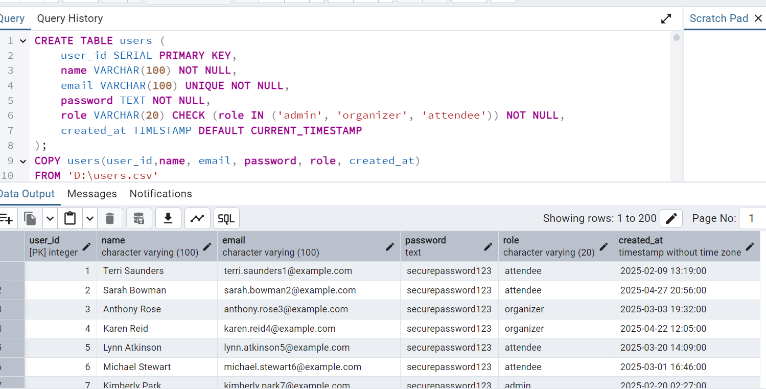

**VENUES**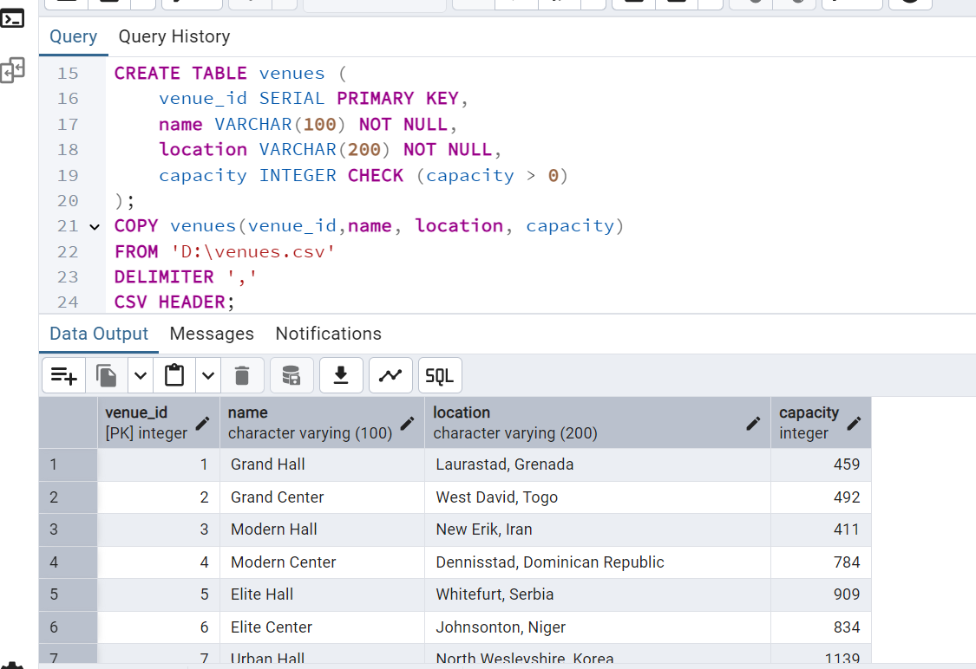

**EVENTS**

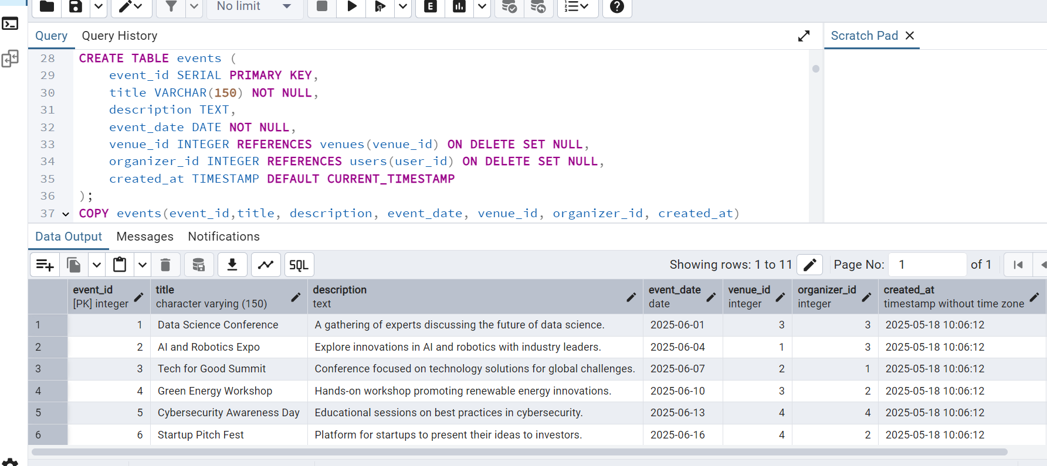

**REGISTRATIONS**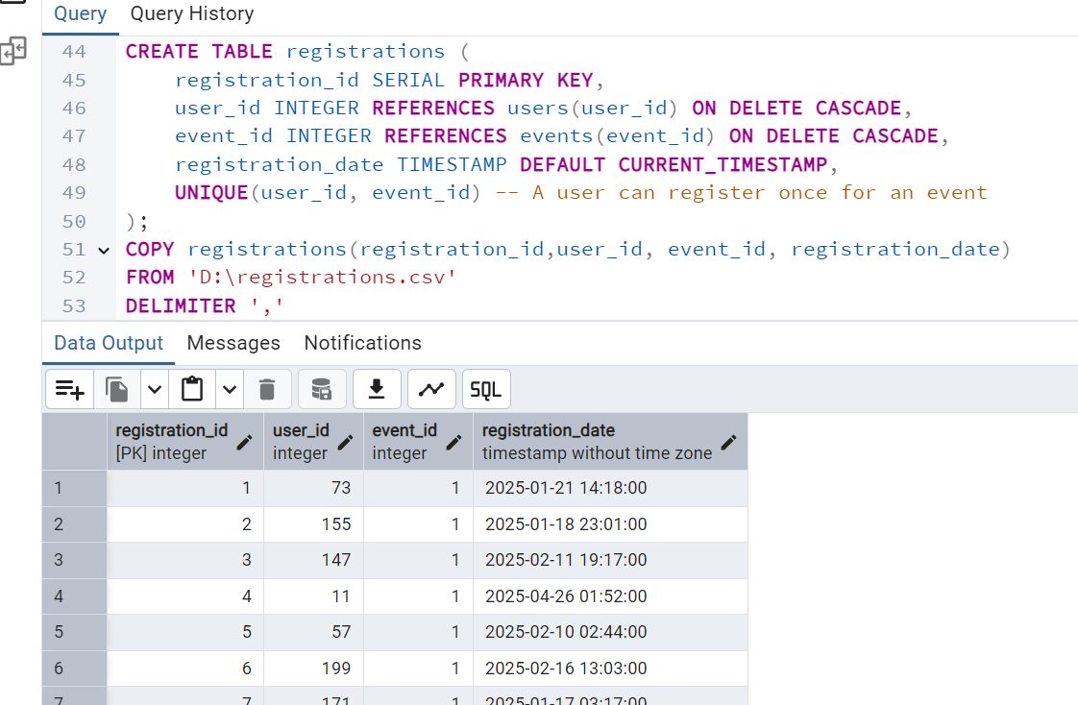

**TICKETS**

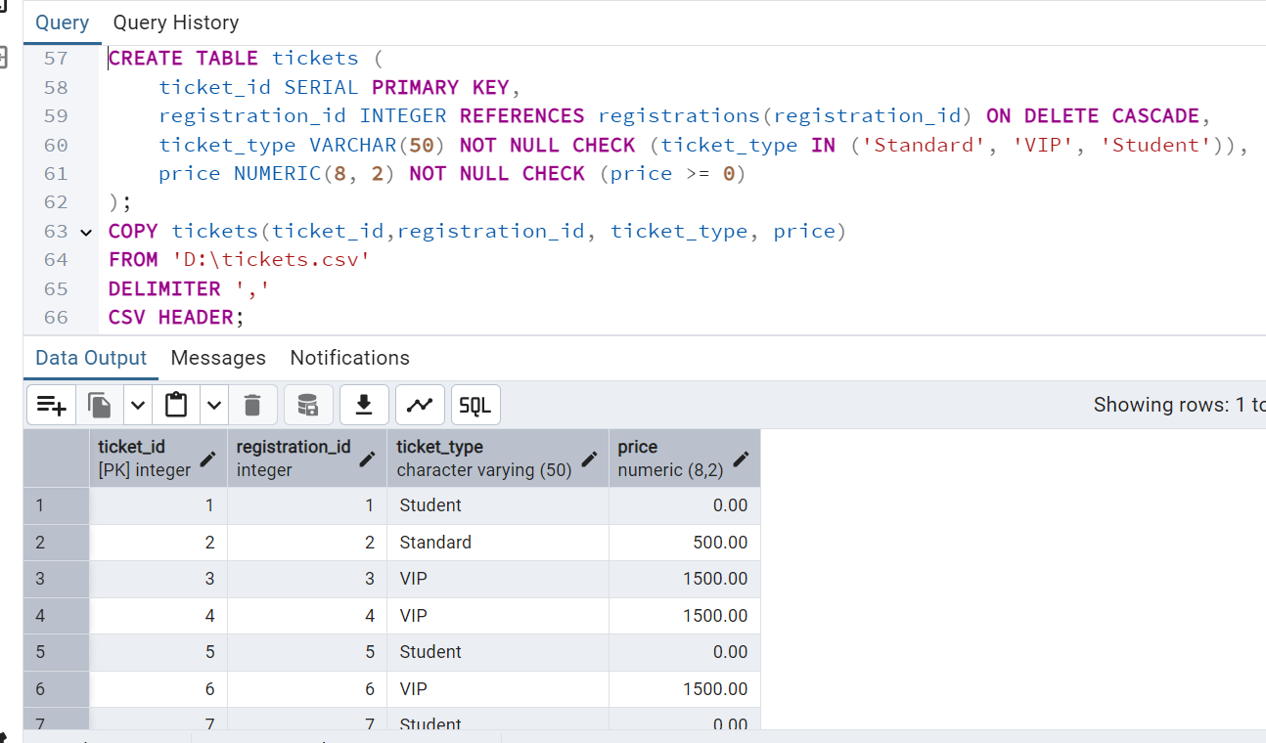

**FEEDBACK**

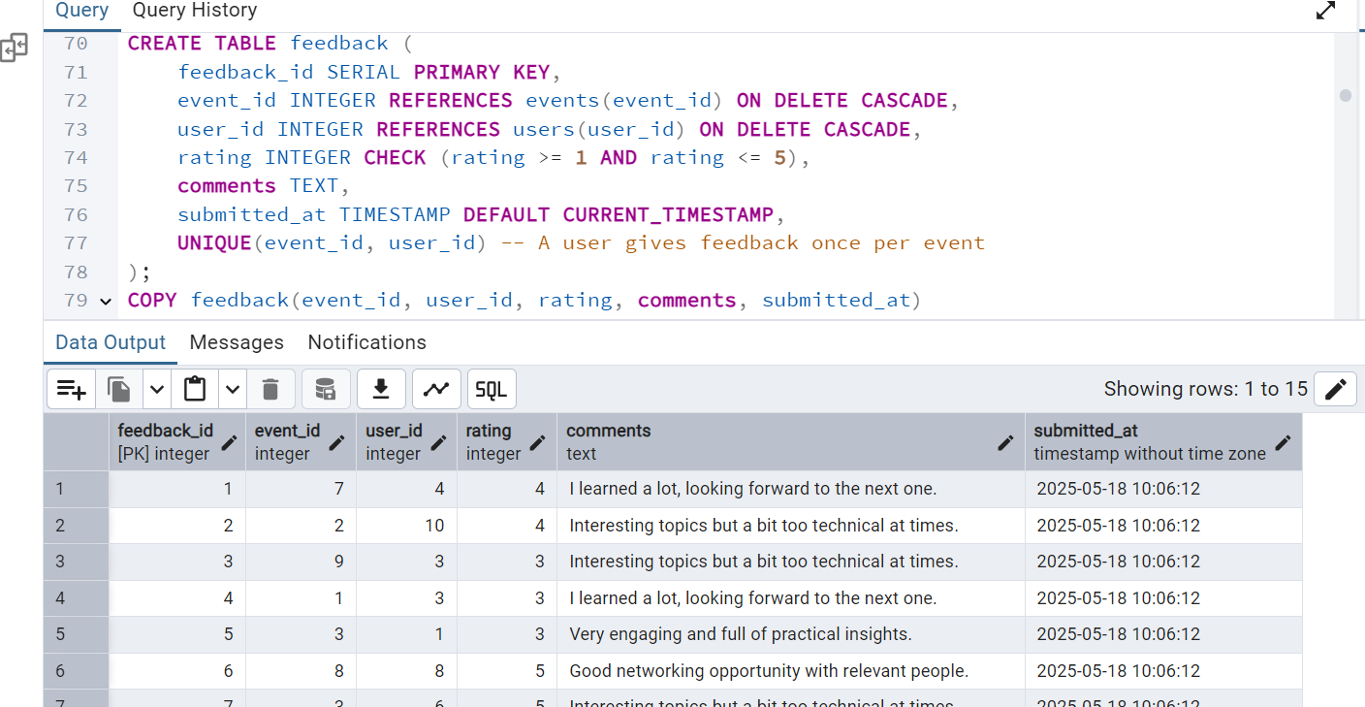

**SIMPLE VIEWS**

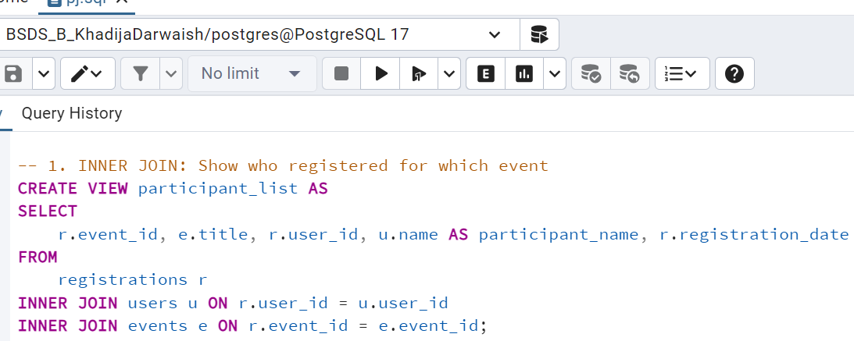

The participant_list view provides a clear summary of event participants.

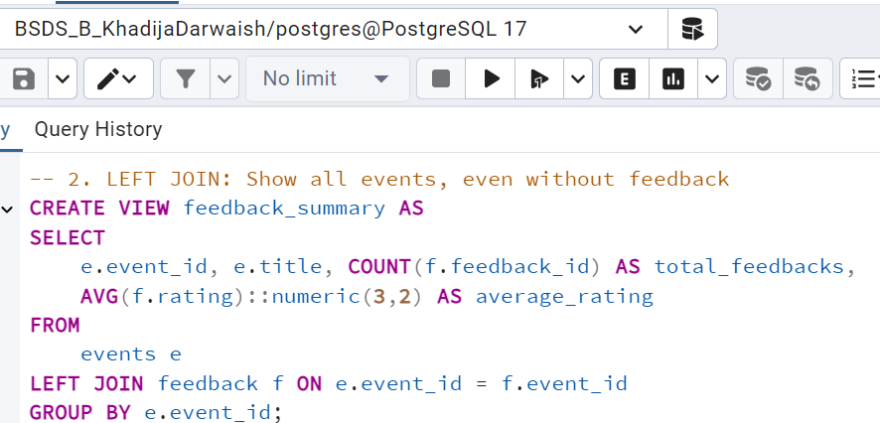

The feedback_summary view offers a concise overview of event feedback. This view is useful for quickly assessing how well events were received.

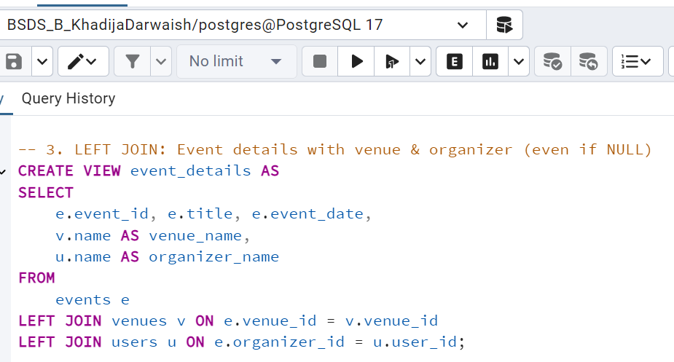

The event_details view provides a comprehensive snapshot of each event by combining key information from the events, venues, and users tables. 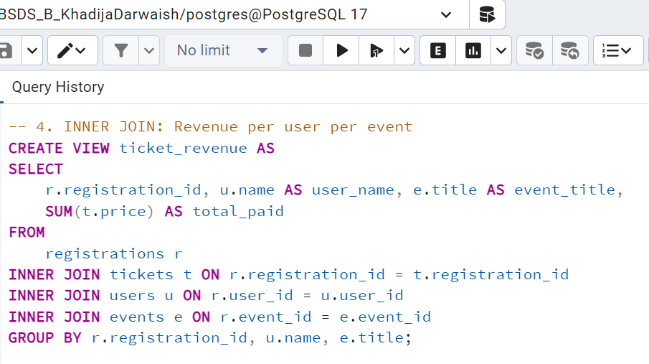 The ticket_revenue view summarizes the total amount paid by each user for their event registrations.

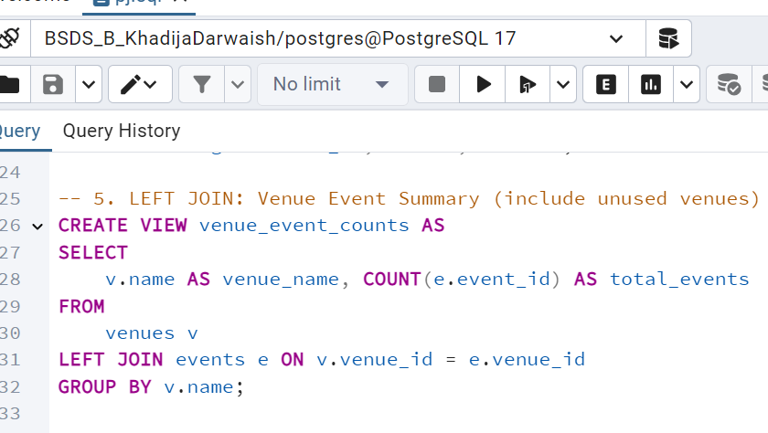

The venue_event_counts view shows the total number of events hosted at each venue.

**MATERIALIZED VIEWS**

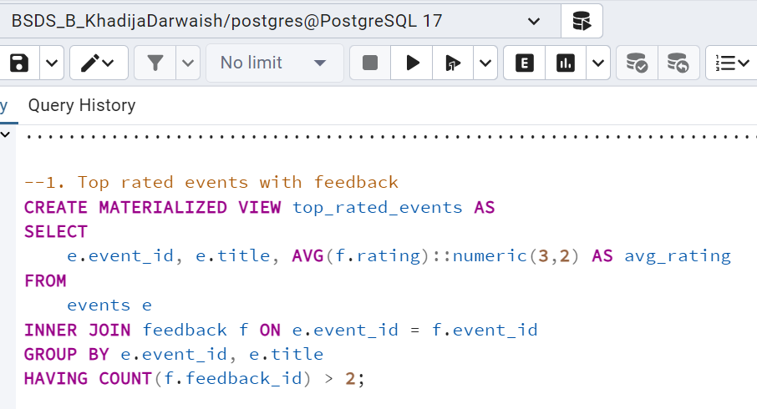The top_rated_events materialized view lists events with strong positive feedback.

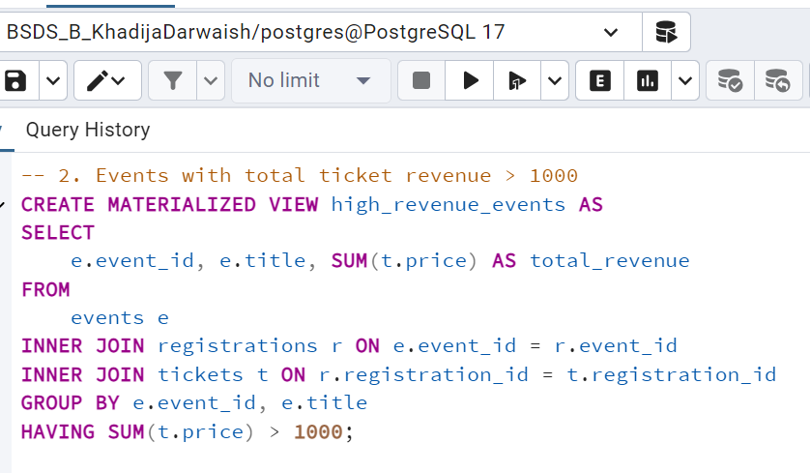 it stores the results physically for faster access but requires manual refreshing to update.

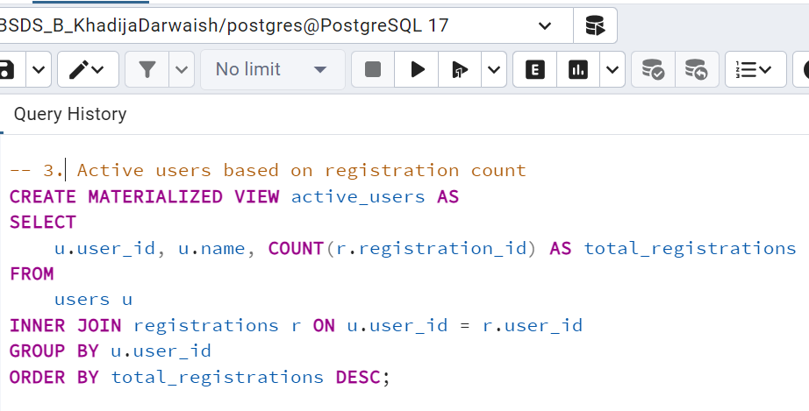 The active_users materialized view ranks users by registration count to highlight the most engaged participants.

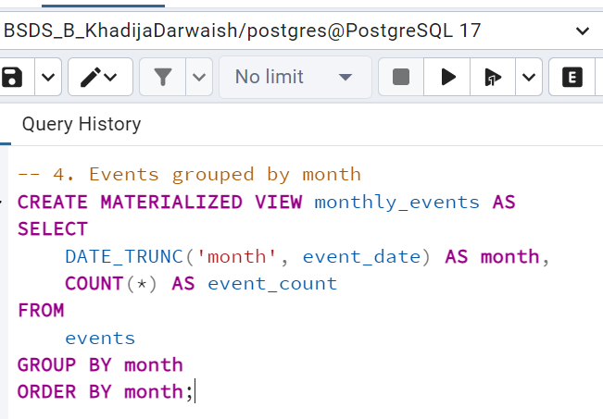 The monthly_events materialized view summarizes the number of events held each month for trend analysis.

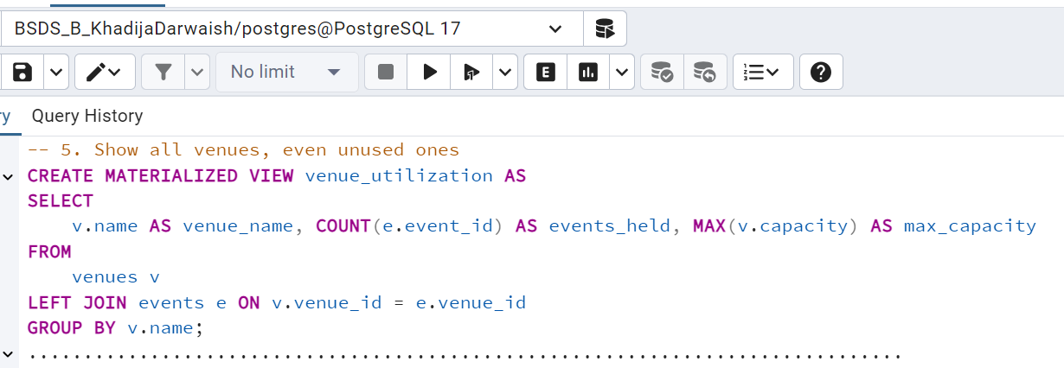 The venue_utilization materialized view shows how often each venue is used and its capacity, aiding in analyzing popularity and space utilization.

**STORED PROCEDURES**

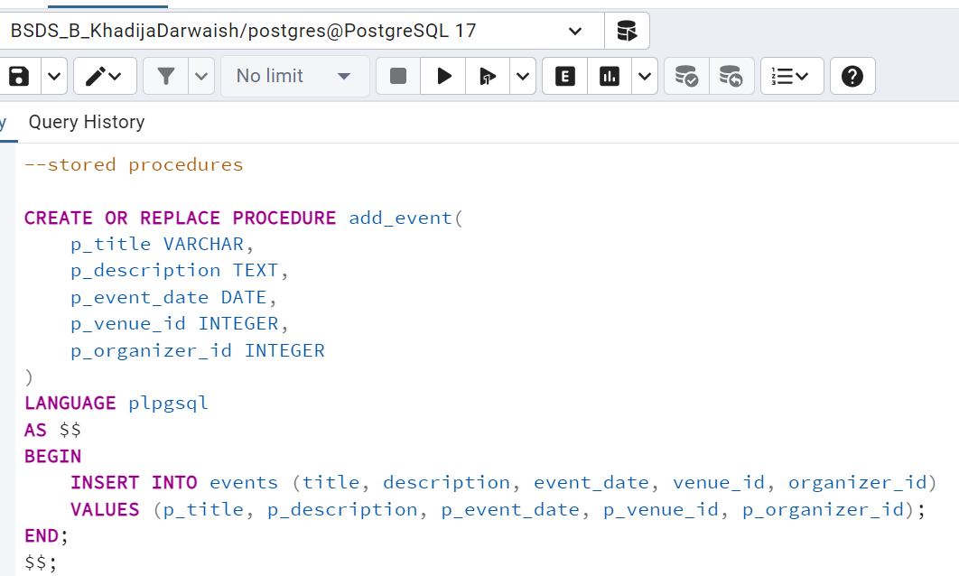 Adds a new event to the events table using the provided title, description, date, venue, and organizer.

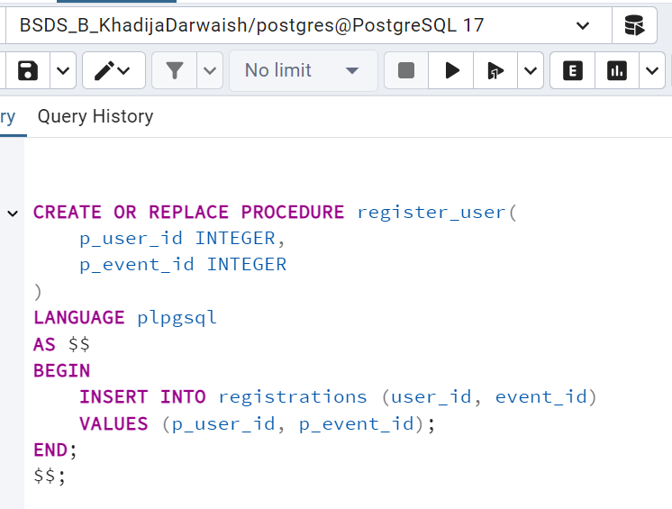 Registers a user for a specific event by inserting a record into the registrations table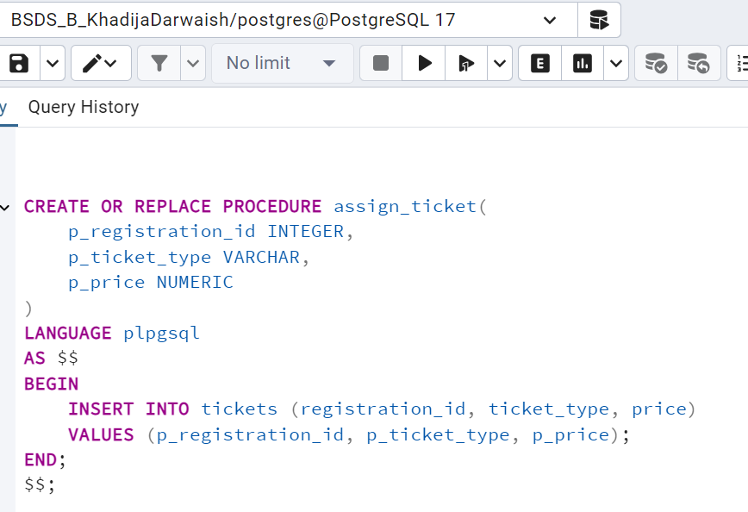Assigns a ticket to a registration with the specified type and price.

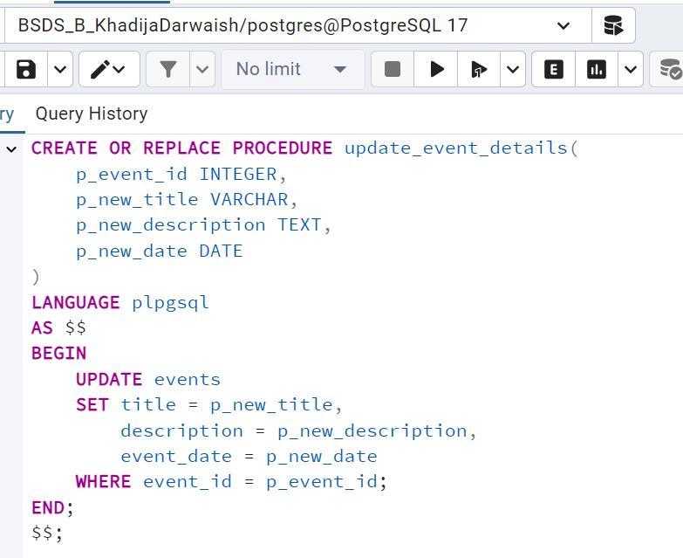Updates the title, description, and date of an existing event based on the event ID.

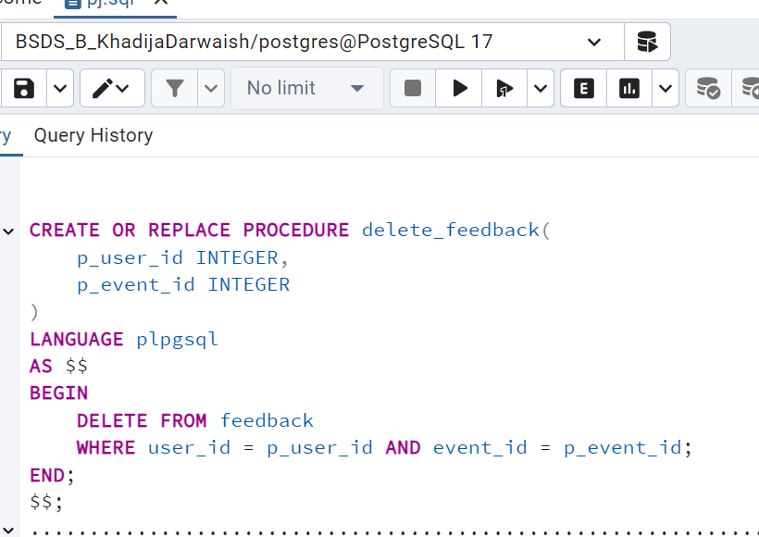Deletes a feedback entry for a specific user and event from the feedback table.

**TRIGGERS**

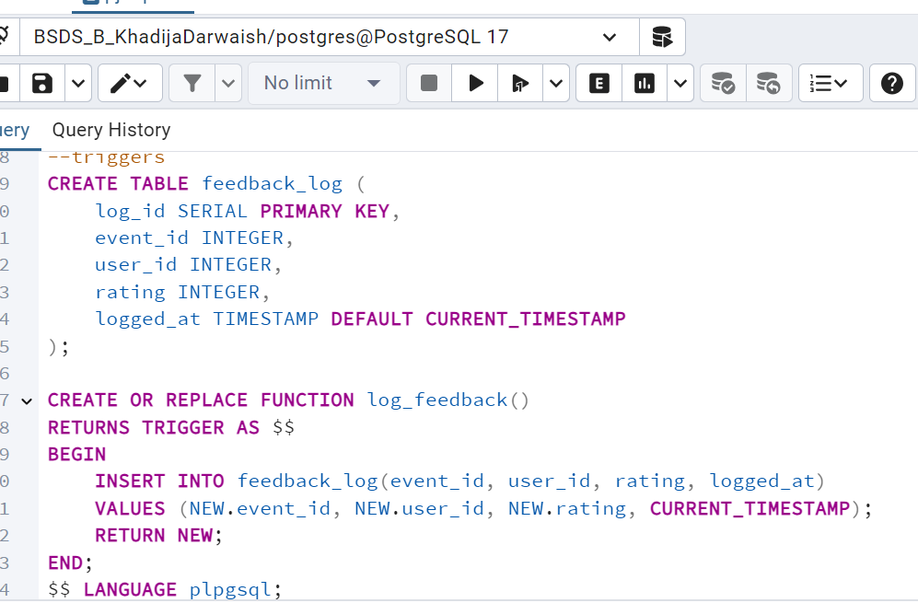

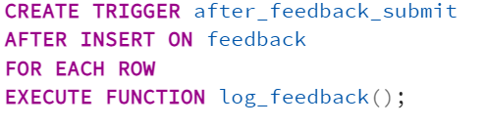 Logs each new feedback entry into the feedback_log table after it’s submitted.

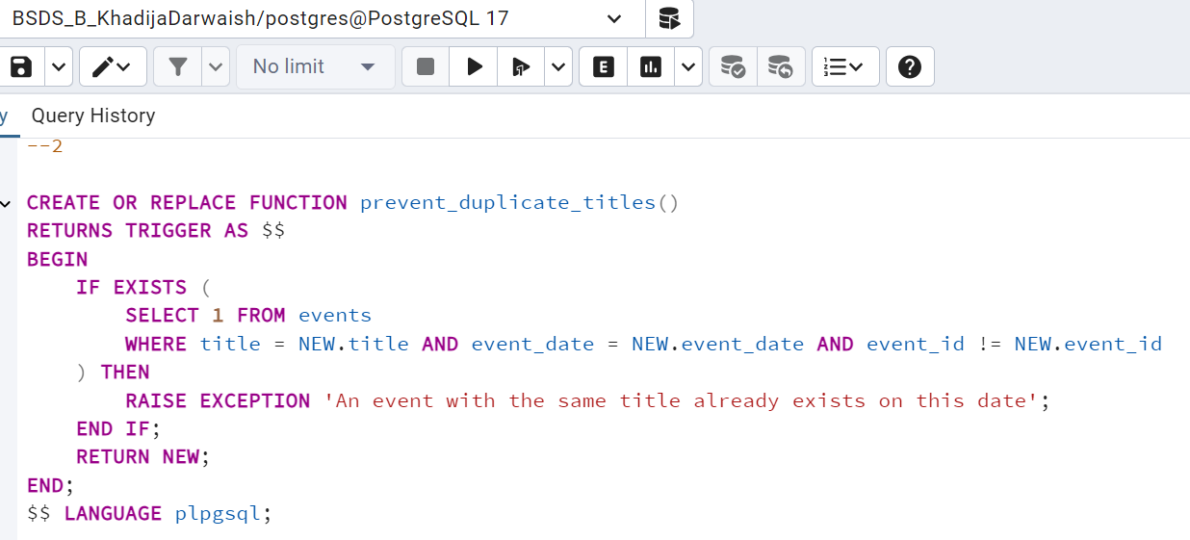

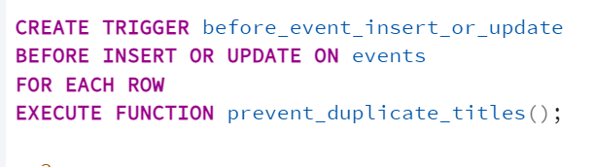 Prevents inserting or updating an event if another event with the same title exists on the same date.

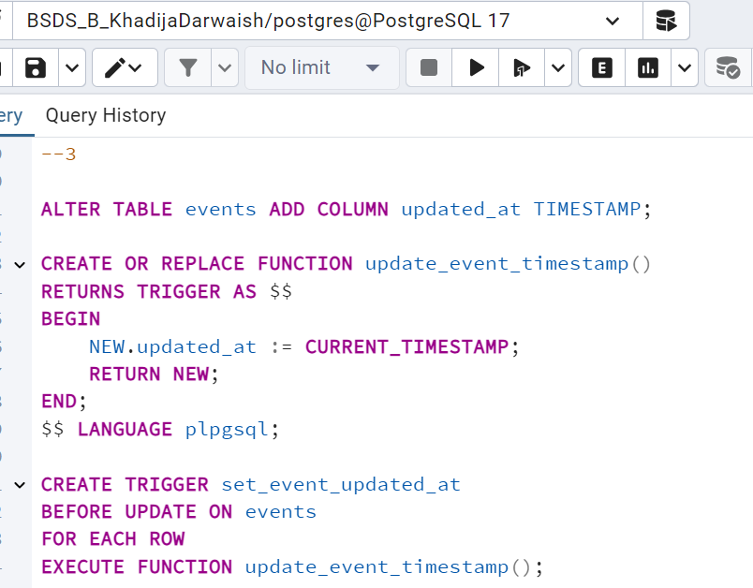 Automatically updates the updated_at timestamp whenever an event is modified.

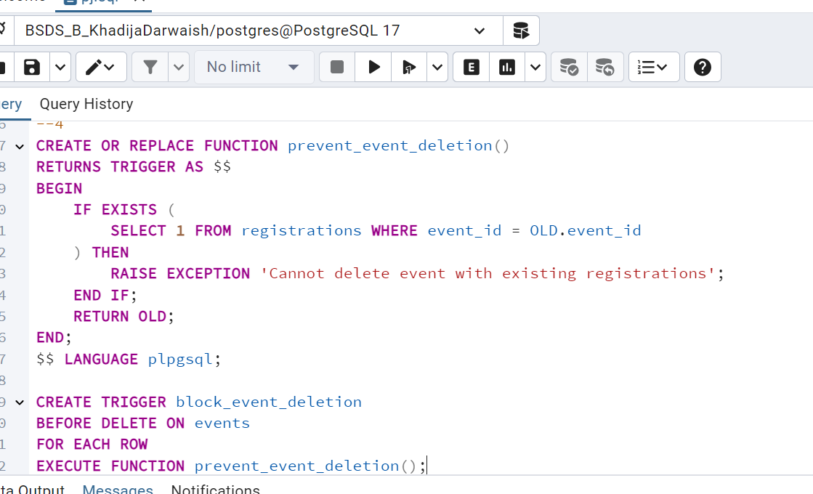 Blocks deletion of an event if it has any associated registrations.

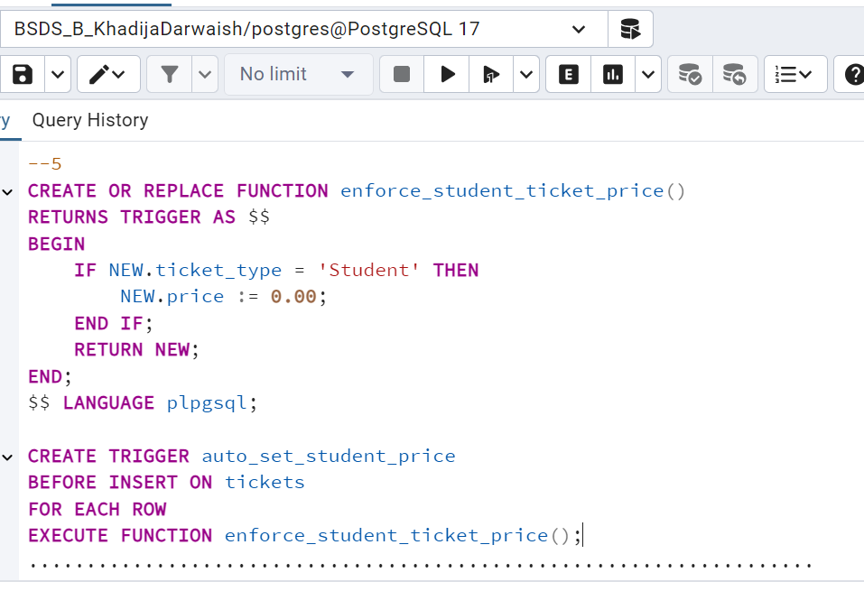 Automatically sets the ticket price to 0.00 for student tickets during insertion.

**FRONT END**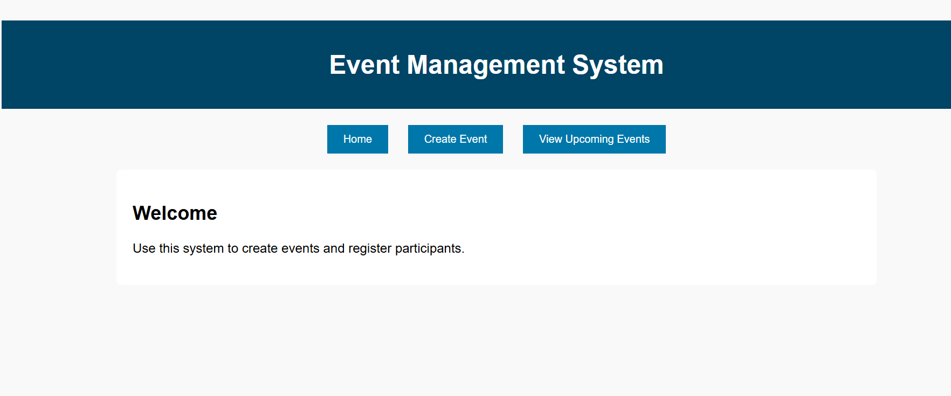

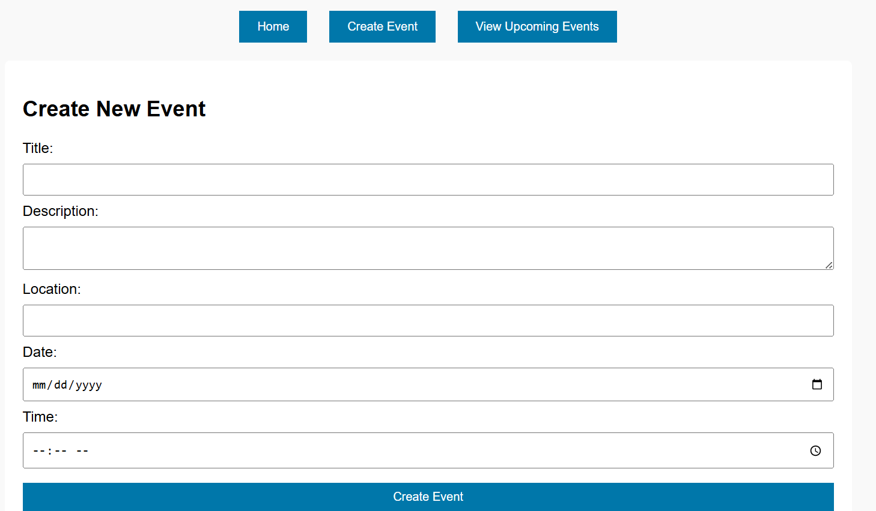

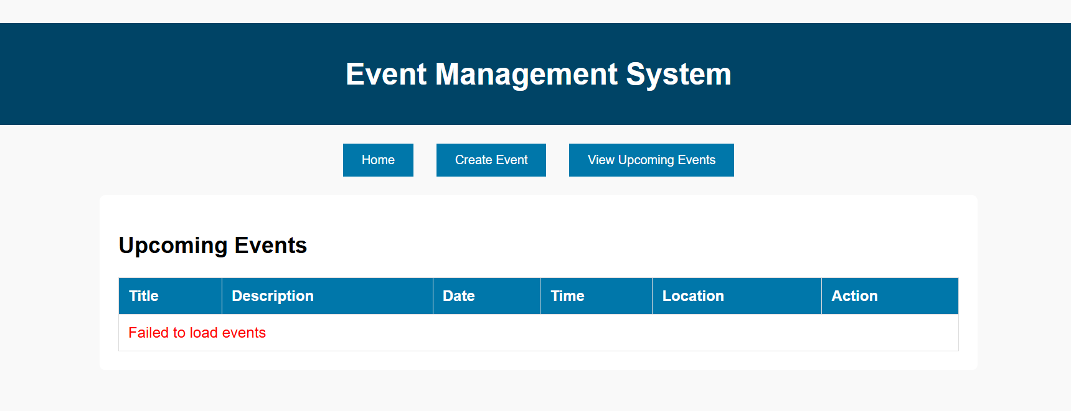

**LINKEDIN SNAPSHOT**

